COMP9331 Lab1

Name: Jiachen Li

StudentID: z5184142

Exercise 1: nslookup

1. Which is the IP address of the Google site ( [www.google.com](http://www.google.com))? In your opinion, what is the reason of having several IP addresses as an output?

The IP addrees of the Google site is 172.217.22.132.

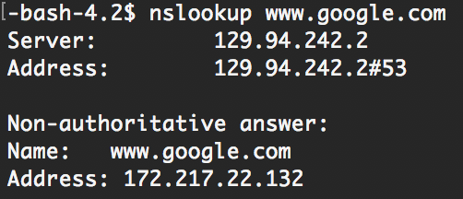

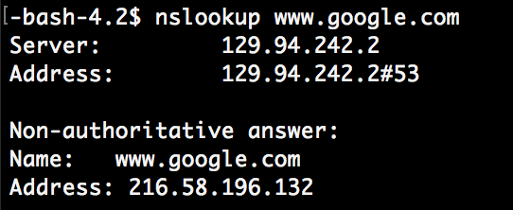

The reason of having several IP addresses as an output is that Google is a search engine website, so the number of visitors per second is very huge, in order to not let one server work overload and keep the service working, then Google needs multiple servers to release the pressure and to ensure that the searching service is always available.

1. Find out name of the IP address 127.0.0.1. What is special about this IP address?

This IP address is the local address.

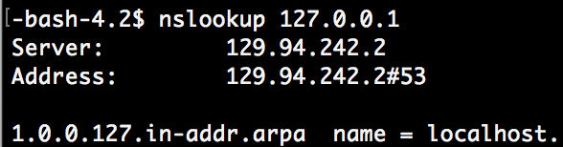

Exercise 2: Use ping to test host reachability

[www.cse.unsw.edu.au](http://www.cse.unsw.edu.au) connected

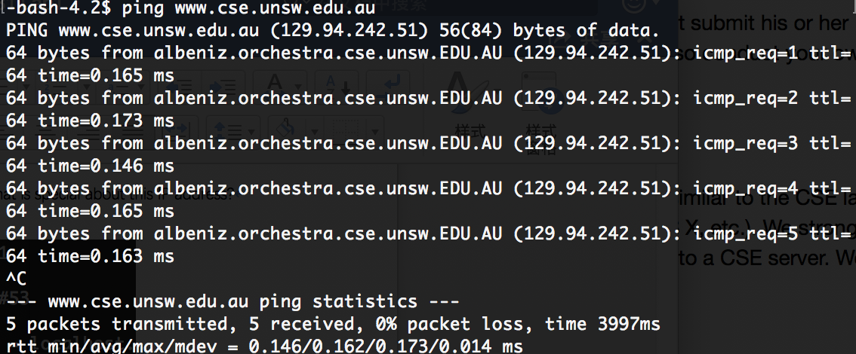

[www.getfittest.com.au](http://www.getfittest.com.au) unknown host

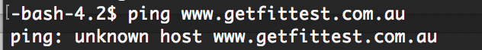

[www.mit.edu](http://www.mit.edu) connected

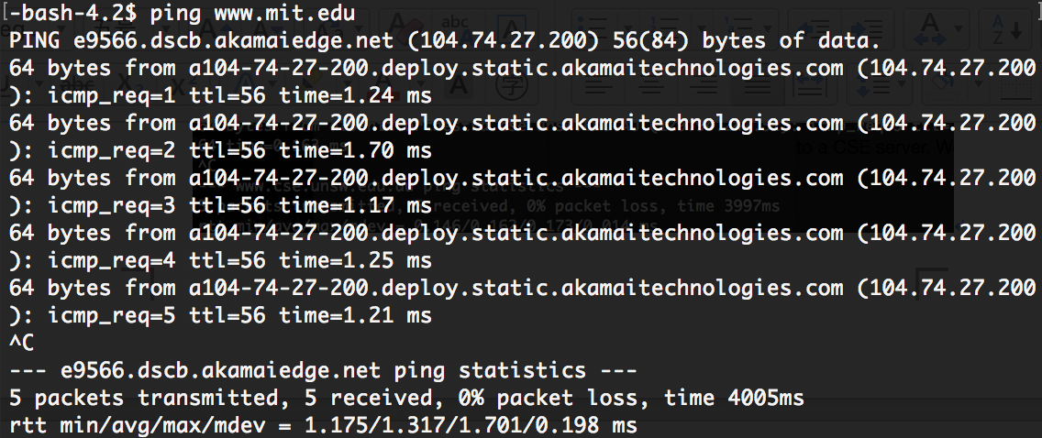

[www.intel.com.au](http://www.intel.com.au) connected

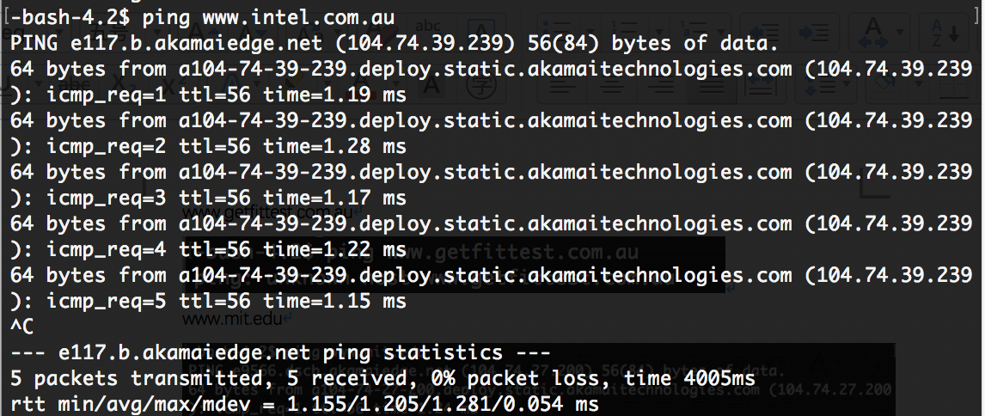

[www.tpg.com.au](http://www.tpg.com.au) connected

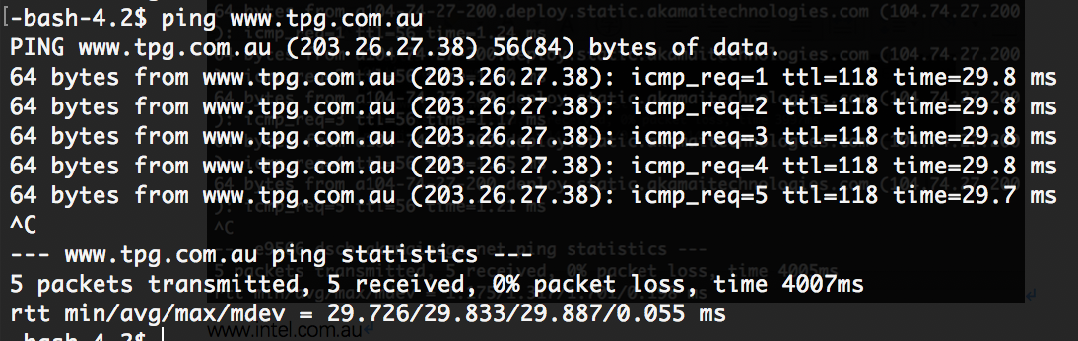

[www.hola.hp](http://www.hola.hp) unknown host

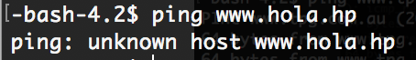

[www.amazon.com](http://www.amazon.com) connected

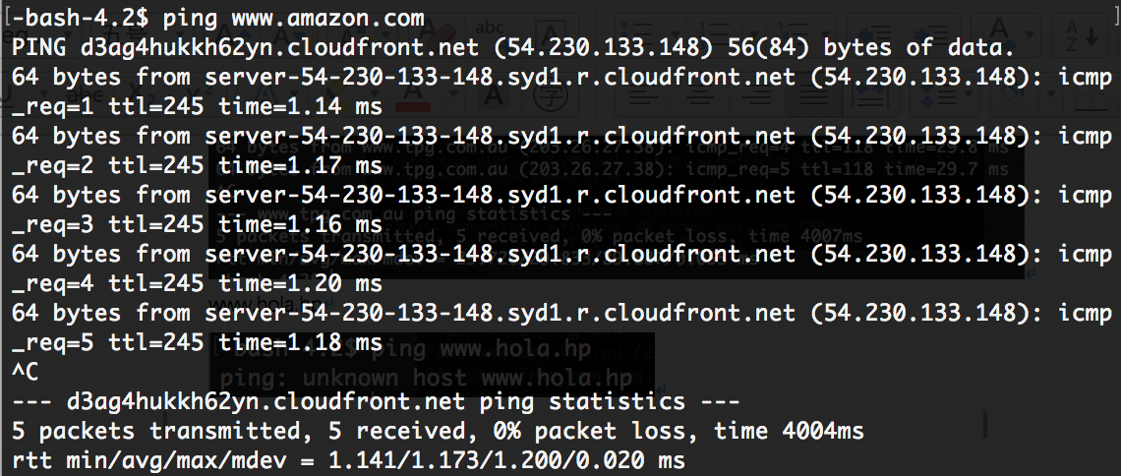

[www.tsinghua.edu.cn](http://www.tsinghua.edu.cn) connected

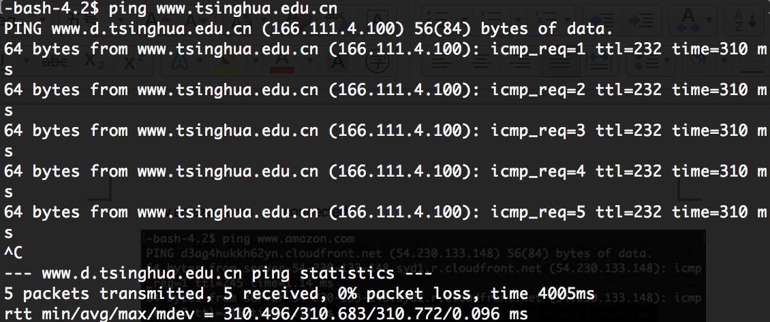

[www.kremlin.ru](http://www.kremlin.ru) ping request can be sent but has no response

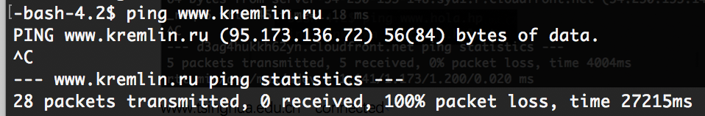

[8.8.8.8](https://webcms3.cse.unsw.edu.au/COMP3331/18s2/resources/8.8.8.8) connected

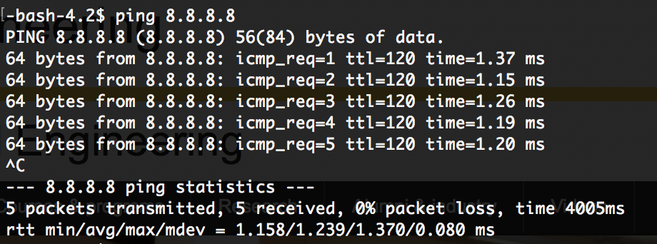

Exercise 3: Use traceroute to understand network topology:

1. How many routers are there between your workstation and www.columbia.edu ?

21 routers. (from cse server to the website server)

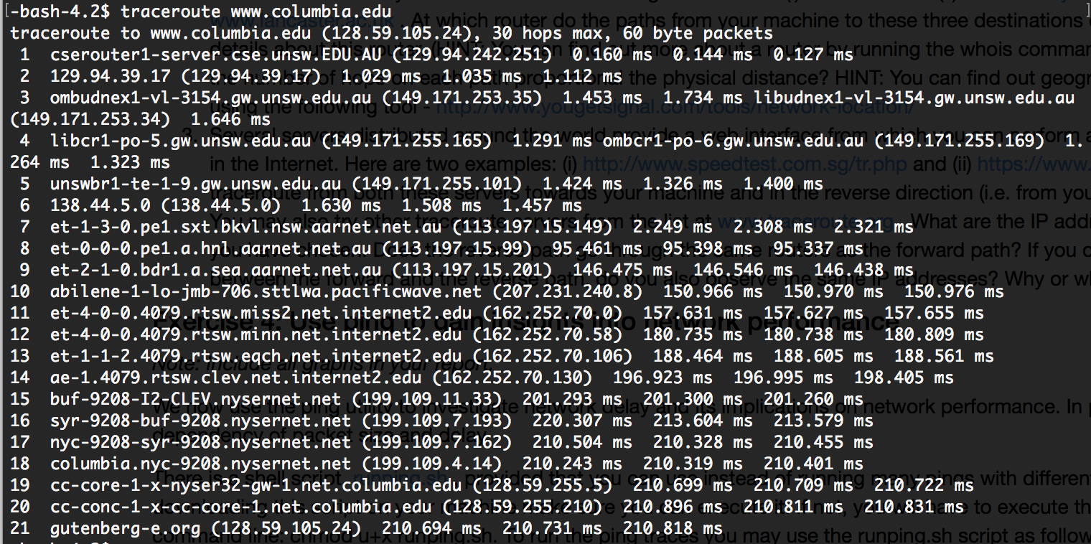

How many routers along the path are part of the UNSW network?

The first five routers are part of the UNSW network.

Between which two routers do packets cross the Pacific Ocean?

Between the 7 and 8 routers, the packets cross the Pacific Ocean, because there is a huge increase in delay, which from almost 2.3ms to 95.4ms.

1. At which router do the paths from your machine to these three destinations diverge?

Find out further details about this router.

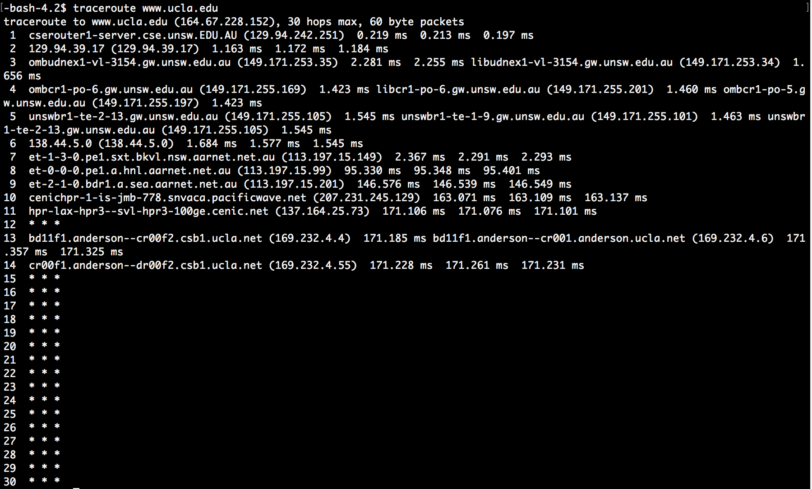

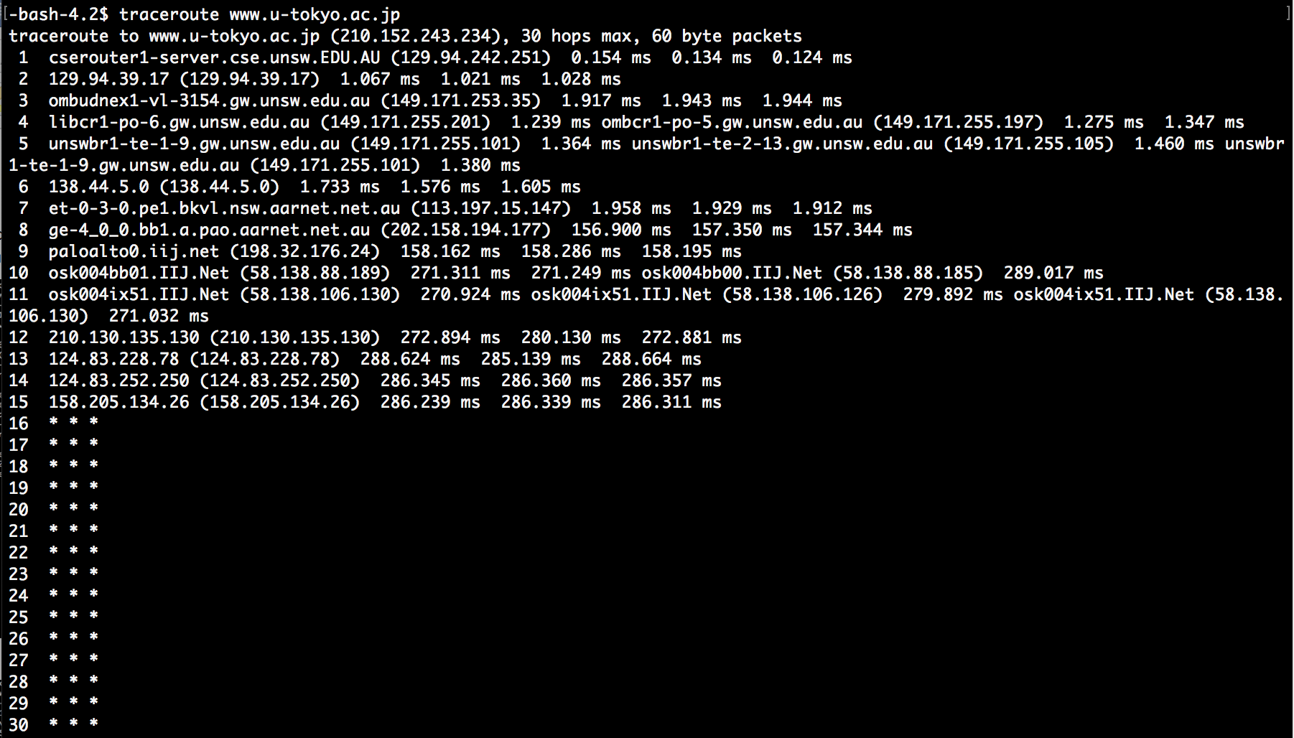

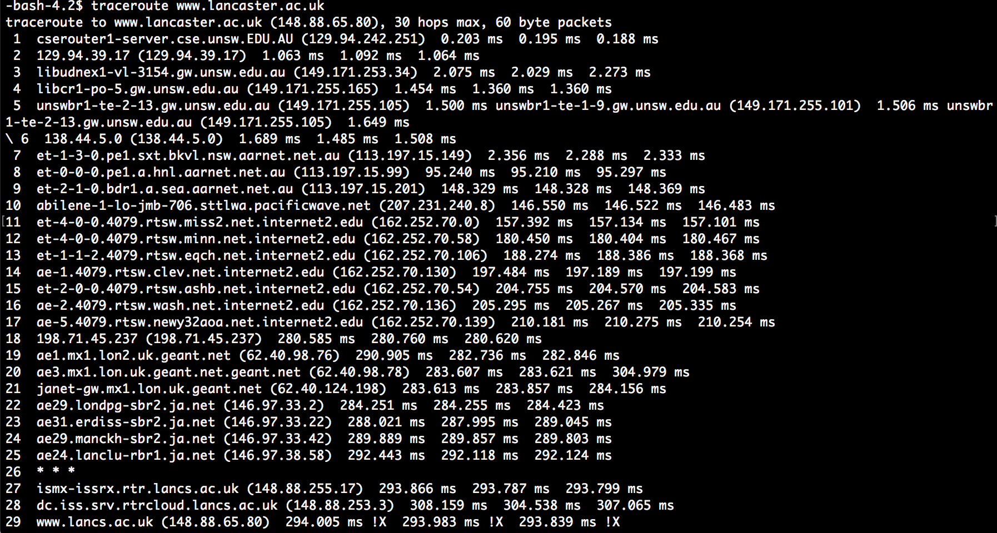

Through the three pictures above, it can be seen that the paths diverge from the third routers.

Is the number of hops on each path proportional the physical distance?

Yes.

[www.lancaster.ac.uk](http://www.lancaster.ac.uk) 10569.8 miles from Syd 29 jumps

[www.u-tokyo.ac.jp](http://www.u-tokyo.ac.jp) 4908.7 miles from Syd 15 jumps

[www.ucla.edu](http://www.ucla.edu) 7499.0 miles from Syd 14 jumps

1. What are the IP addresses of the two servers that you have chosen. Does the reverse path go through the same routers as the forward path? If you observe common routers between the forward and the reverse path, do you also observe the same IP addresses? Why or why not?

From <http://www.speedtest.com.sg/tr.php> to my machine,

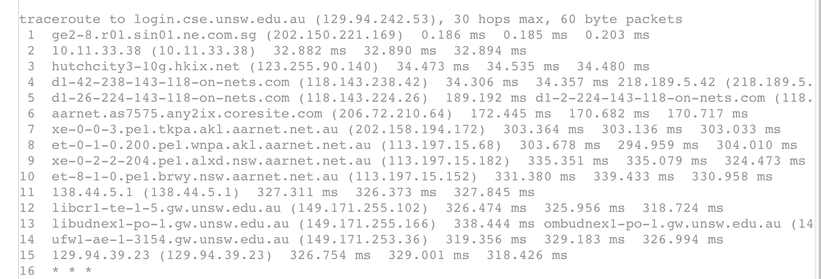

From <https://www.telstra.net/cgi-bin/trace> to my machine,

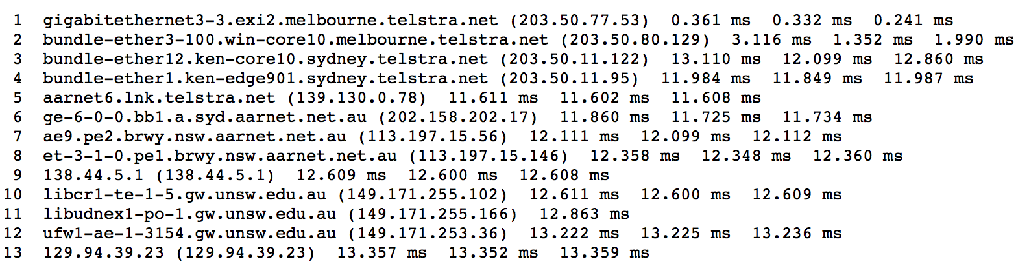

From my machine to [www.speedtest.com](http://www.speedtest.com),

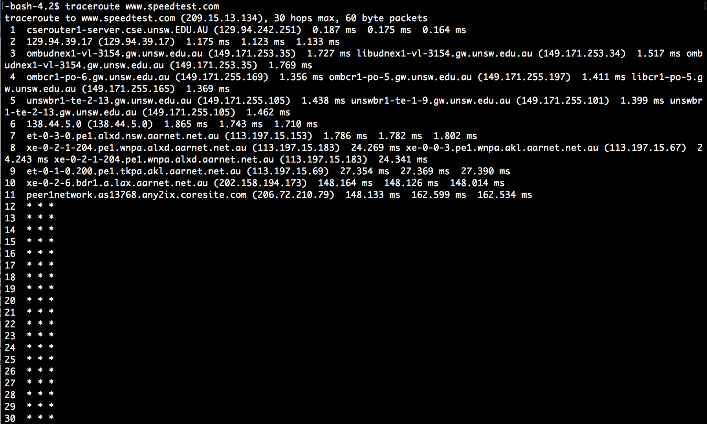

From my machine to [www.telstra.net](http://www.telstra.net),

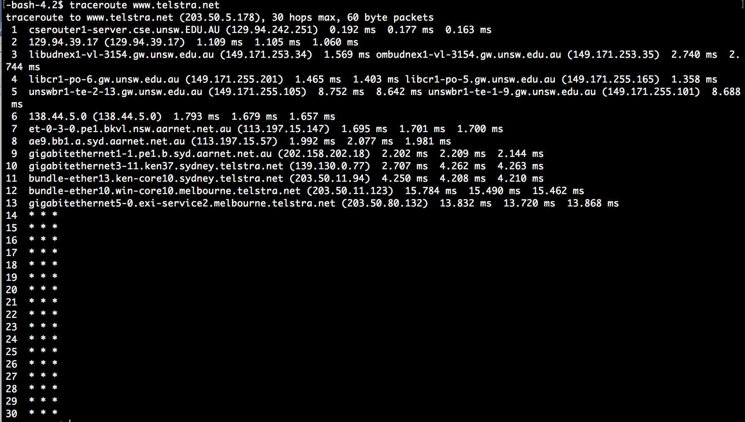

I have chosen <http://www.speedtest.com.sg/tr.php> and <https://www.telstra.net/cgi-bin/trace>. From the pictures above, it can be seen that the reverse path does not go through the same routers as the forward path. The IP address of the common routers between forward and the reverse path is also not the same. I think it is because the routing policy using on these routers or the best path is also changing.

Exercise 4: Use ping to gain insights into network performance

1. From UNSW to Brisbane, the direct physical distance is 737.25 kilometers.

T = 737.25/light speed = 2.46ms

From UNSW to Singapore, the direct physical distance is 5962.46 kilometers.

T = 5962.46/light speed = 19.87ms

From UNSW to Berlin, the direct physical distance is 16106.19 kilometers.

T = 16106.19/light speed = 53.69ms

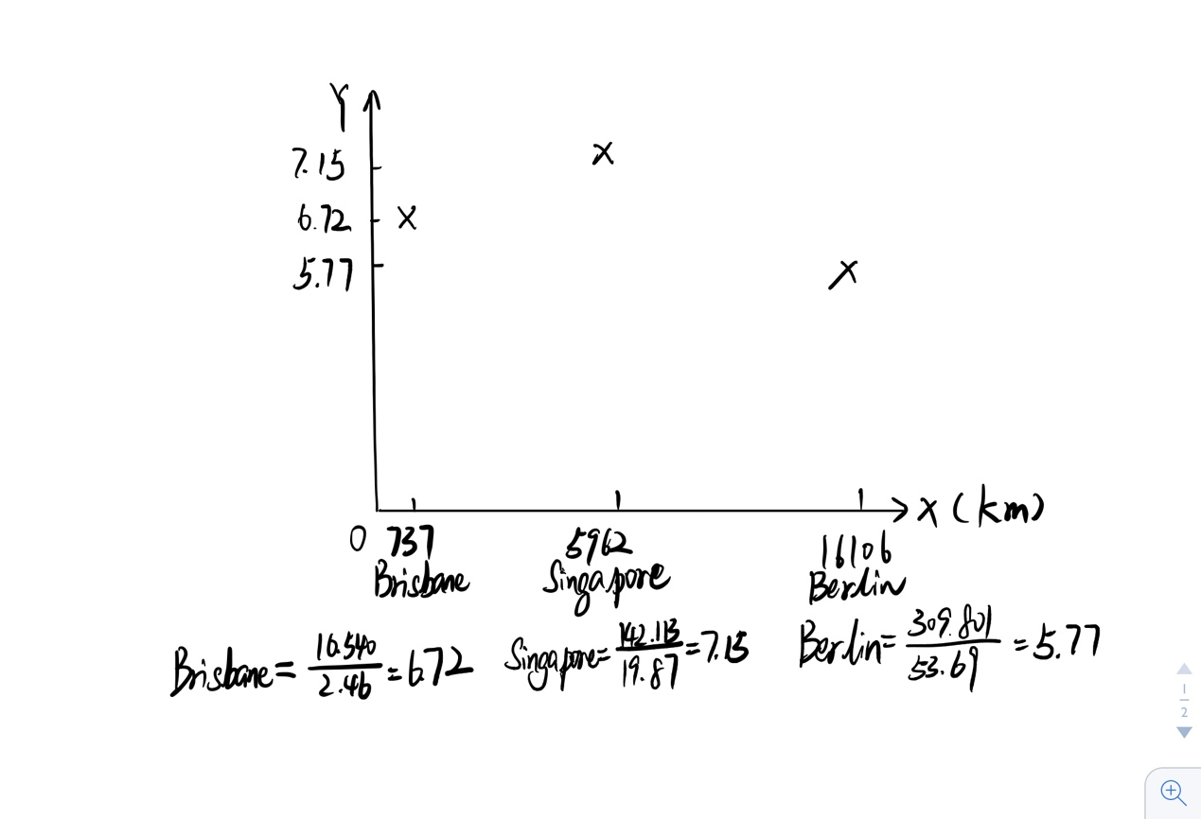

Can you think of at least two reasons why the y-axis values that you plot are greater than 2?

Because the packets could be affected by network congestion, switch-routing policy used on the routers (especially the quality of service policy), the bandwidth of the network and so on.

1. Is the delay to the destinations constant or does it vary over time? Explain why.

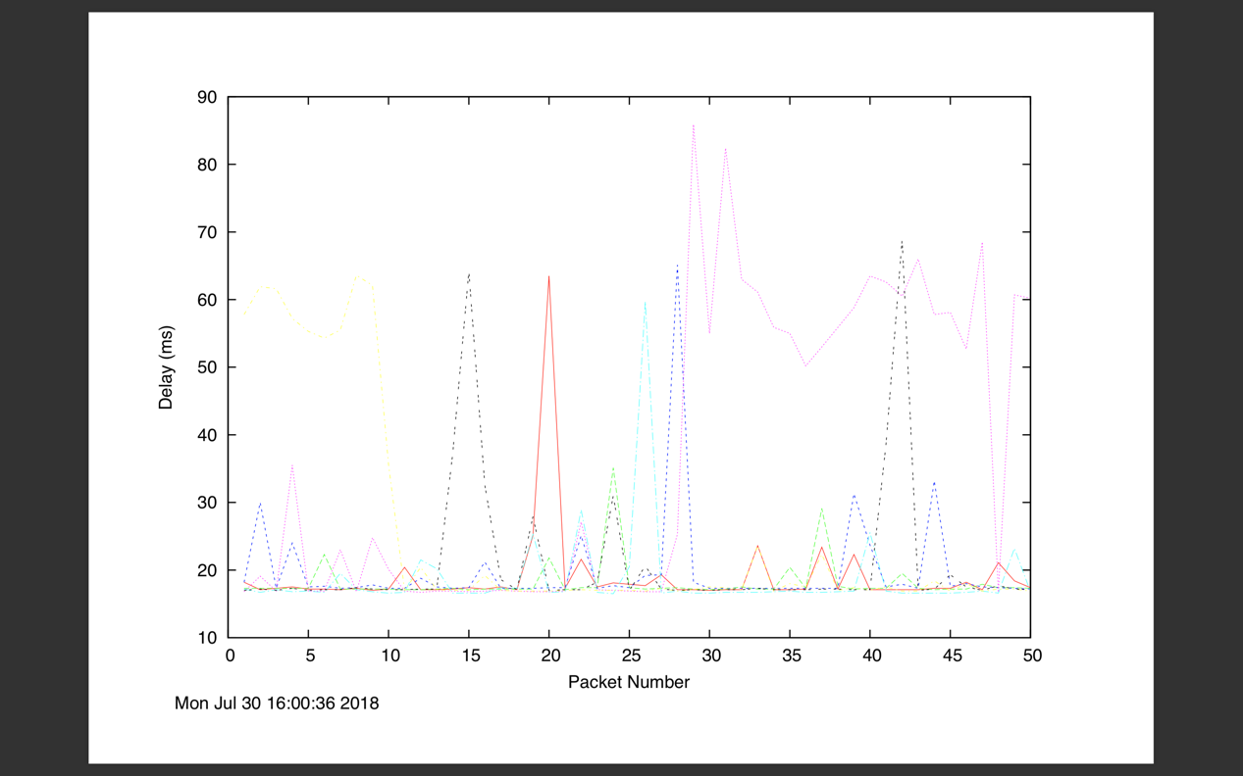

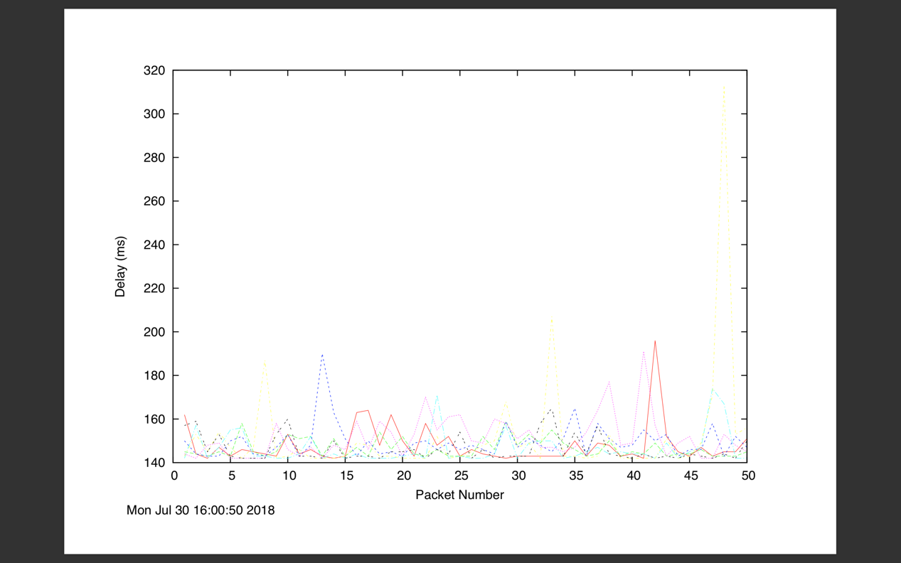

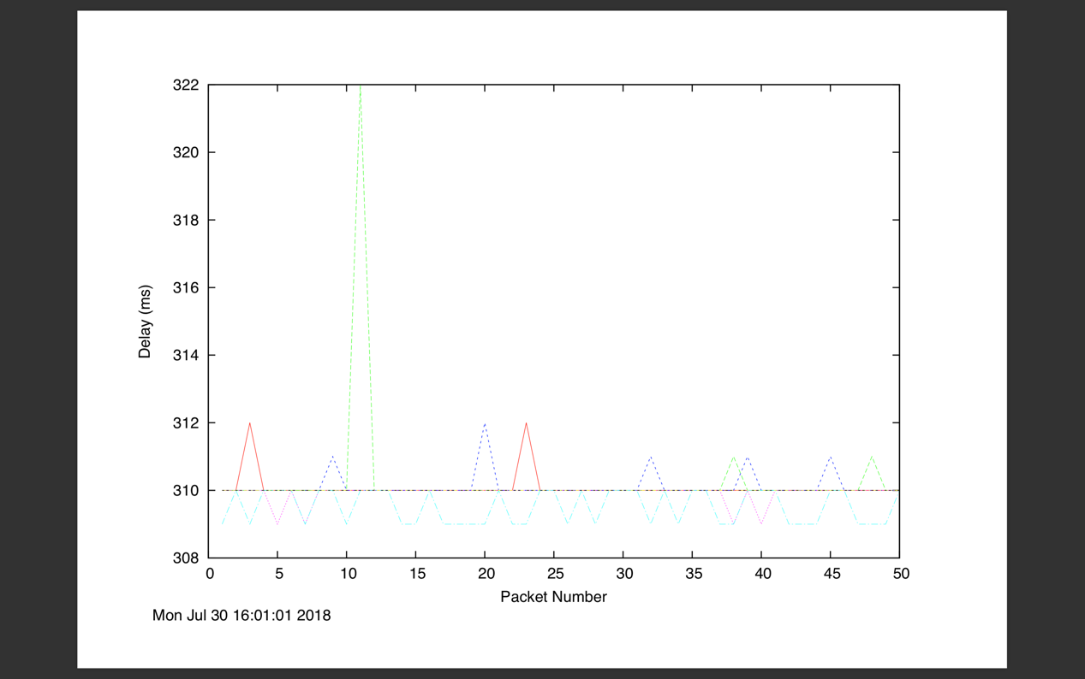

From the graphs above, the delay to the destinations varies over time. The reason why the delay to the destinations varies over time is that the environment of the network varies, such as the vary of the network traffic.

1. The measured delay (i.e., the delay you can see in the graphs) is composed of propagation delay, transmission delay, processing delay and queuing delay. Which of these delays depend on the packet size and which do not?

Propagation delay, queuing delay and processing delay do not depend on the packet size.

Transmission delay depends on the packet size.